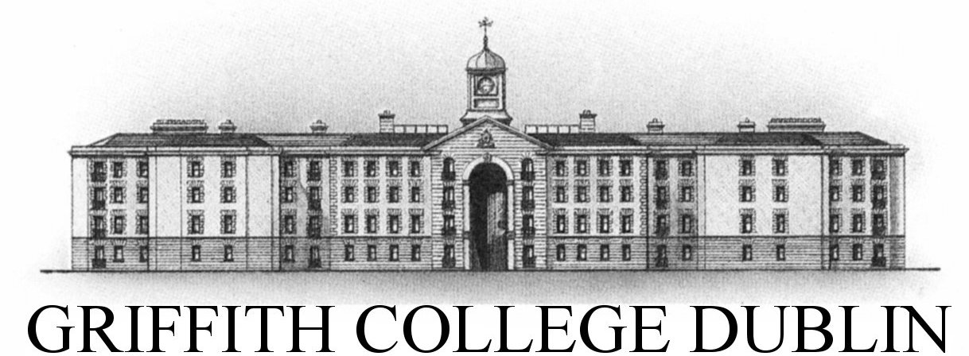

#### Assignment Cover Sheet

|  |  |  |  |  |  |  |
| --- | --- | --- | --- | --- | --- | --- |
| **Student name:** | **Rhyder Quinlan** | | | | | |
| **Student number:** | **2913880** | | |  | | |
| **Faculty:** | **Computing Science** | | |  | | |
| **Course:** | **BSc** | | | **Stage/year:** | **1** | |
| **Subject:** | **Computer Programming** | | | | | |
| **Study Mode:** | Full time | **Yes** |  | Part-time |  |  |
| **Lecturer Name:** | **Eoin Carroll** | | | | | |
| **Assignment Title:** | **Take Home Assignment 4** | | | | | |
| **No. of pages:** | **-** | | |  | | |
| **Disk included?** | No |  |  |  |  |  |
| **Uploaded to Moodle?**  **Additional Information:** | Yes  (ie. number of pieces submitted, size of assignment, A2, A3 etc) | | | | | |
|  | | | | | |
|  | | | | | |
| Date due: | **23/04/2017** | | |  | | |
| Date submitted: | **23/04/2017** | | |  | | |
|  | | | | | | |
| **Plagiarism disclaimer:**  *I understand that plagiarism is a serious offence and have read and understood the college policy on plagiarism. I also understand that I may receive a mark of zero if I have not identified and properly attributed sources which have been used, referred to, or have in any way influenced the preparation of this assignment, or if I have knowingly allowed others to plagiarise my work in this way.*  *I hereby certify that this assignment is my own work, based on my personal study and/or research, and that I have acknowledged all material and sources used in its preparation. I also certify that the assignment has not previously been submitted for assessment and that I have not copied in part or whole or otherwise plagiarised the work of anyone else, including other students.*  **Signed: Rhyder Quinlan Date: 23/04/2017** | | | | | | |

## 

## Please note: Students MUST retain a hard / soft copy of ALL assignments